
 | Flower Garden Activity

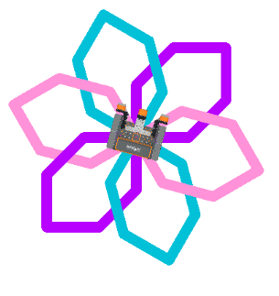

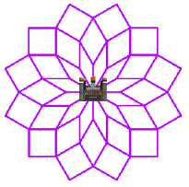

Draw flowers using a virtual robot, code, and your creativity!


Step-By-Step:
- Open VEXcode VR by navigating to vr.vex.com.
  - Use the Open Playground button in the Toolbar to open the Playground Window.

  - Choose Art Canvas.
- Build the starter code on the next page or download the project file linked here. Then run the project by pressing the Start button.
- After the first petals are drawn, add onto the project to finish your flower. You can customize your flower by changing:
  - The number of petals
  - The color of each petal

  - The size of the petals
- Use Start to test your project and see how your flower looks! Use the Reset button to reset the Playground between each run.

Reminders & VEXcode VR Tips
- Use Loops – Many of the same blocks are used for each petal. Add Repeat loops to help you build your project.
- Change Colors and Width –
  - Use the Set pen width block to adjust the width of your lines. The default width is thin.
  - Use the Set pen color block to customize the color of the lines drawn by the robot.
- Look for help – More information about the Playground and the blocks available to use with the VR Robot is available at api.vex.com.

Flower Garden Starter Code:
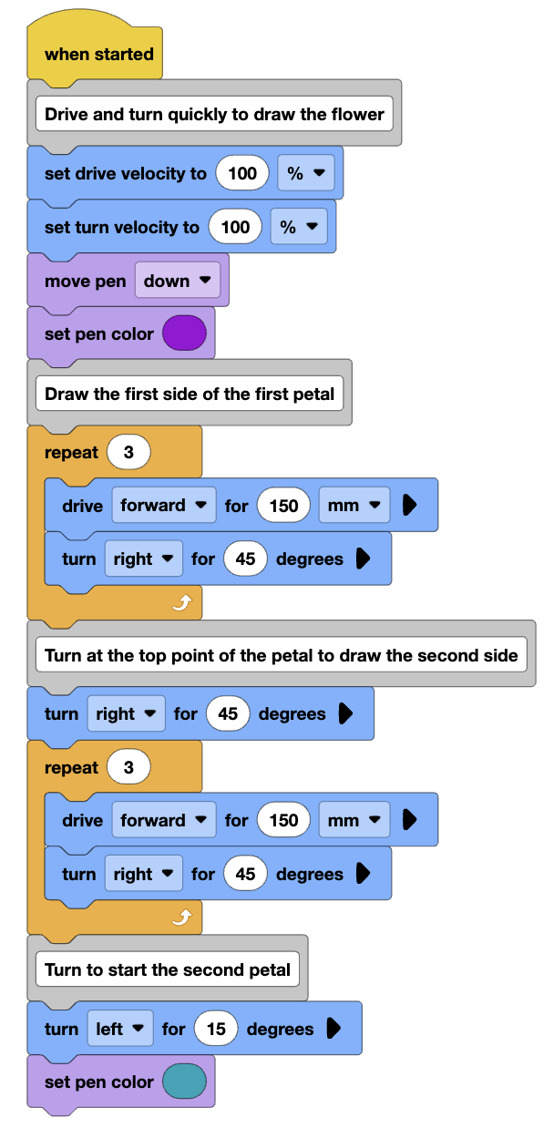
Flower Garden
Activity Notes

Hands-on time for this activity is approximately 30-45 minutes.

Facilitating the Flower Garden Activity
- Introduce the activity. Share the context here to help students connect creativity and code.
 | Code is not only used to move robots or solve problems. It can also be used to create music, design animations, make video games, build websites, control light displays, and create digital art. In each of these examples, someone uses code to make creative choices: what should happen, when it should happen, what it should look like, and how someone else will experience it.  In Flower Garden, you will use code as a creative tool. You will code the VR Robot to draw a flower by choosing movements, turns, colors, and patterns. As you work, think like both a coder and an artist. Test your ideas, notice what changes, and revise your code to make your flower garden your own.
- Build and test the sample code with students.
  - Launch VEXcode VR, choose the Art Canvas Playground and build the sample code together. Use tools like Duplicate as you build the project with students to show how to easily replicate stacks of blocks.
    - You can also download the project code file linked here.
  - Have students run the project when finished building. Once all groups have learned how to build and run a project and how to reset the Playground, have them begin adding on to the project to complete their flower.
- Circle the room and facilitate by asking questions and/or sharing strategies to help students complete the activity.
  - Questions to ask:
    - What flower are you creating? How did you decide on that flower?
    - How is your group taking turns as you design and code your flower?
    - How do you think the turns of the robot relate to how the finished flower looks?
  - Strategies to share:
    - Students may need help connecting each block to the behavior of the robot. They can use the Step button in VEXcode VR to control when each block runs. See this article about stepping through a project to learn more.
    - Encourage students to use Comment blocks to organize their code.
To extend this activity, encourage students to add on to their existing projects. They can create additional flowers in the same project or add stems and details to their beginning flower.

